1. GitHub Repo: https://github.com/jbr-ish/IT3200/tree/main/Module%206

2. Working Application:
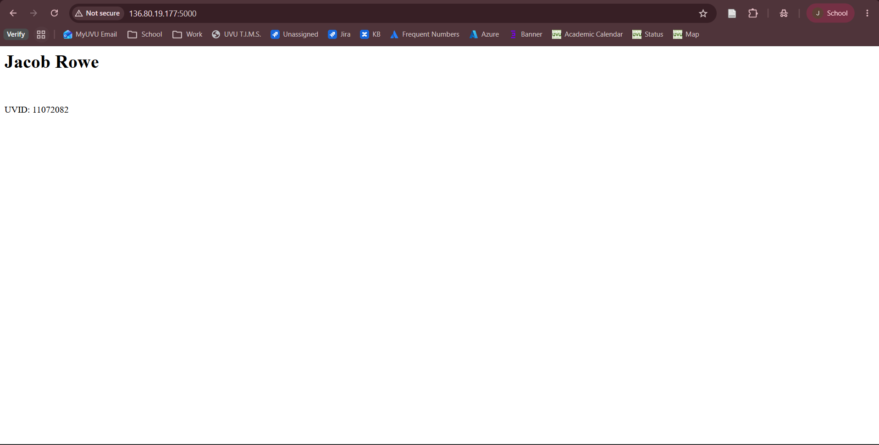
3. Cloud VM
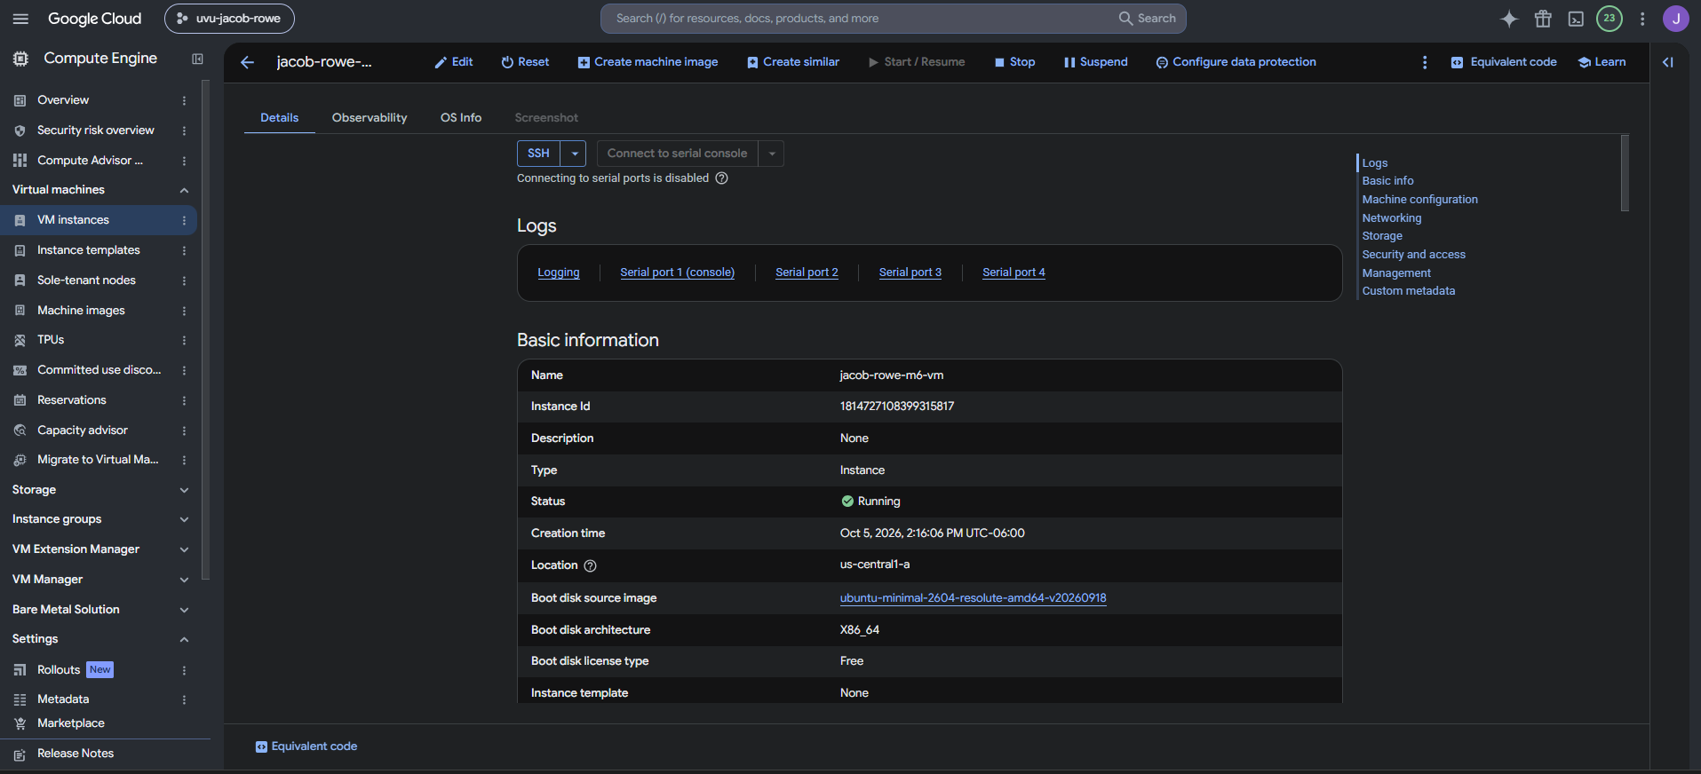
4. Docker Process
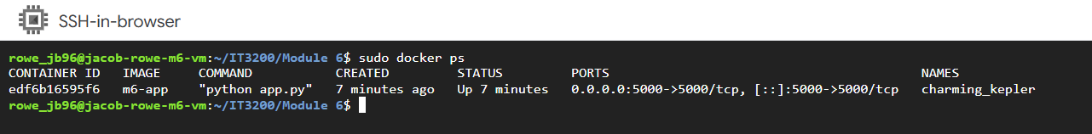
5. Firewall Rule
